SRS 706.0 Fees and Costs Disclosed - Worked example

Purpose
This document details a simplified example of reporting under “SRS 706.0 Fees and Costs Disclosed” (SRS 706.0) to provide clarity and promote consistency in compiling pilot data and submission responses for consultation on this topic.
An Excel file is enclosed at the end of this document to provide further illustration.

SRF 706.0: Table 1, Fees and costs arrangements
In the example for this table, a fund is presented with the following characteristics:
- Three fees and costs arrangements:
  - a standard fees and costs arrangement for the general membership of the fund.
  - a custom fees and costs arrangement which is offered to 10 employers. All 10 employers are offered the same rate.
  - a fee arrangement for DB members.
- 1 million members with $100 billion in assets.
- Of the three fees and costs arrangements, only the standard fees and costs arrangement has transitioned to updated requirements under “Regulatory Guide 97: Disclosing fees and costs in PDSs and periodic statements” (RG 97).

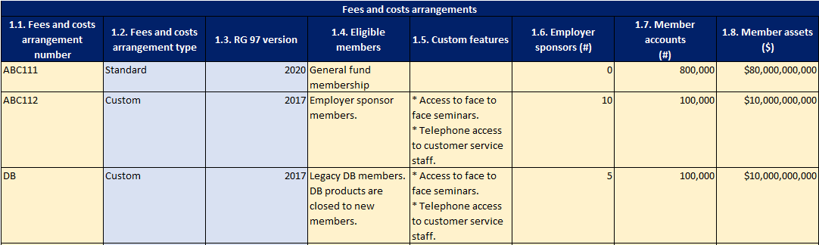

SRF 706.0: Table 2, Fees and costs arrangements

The example fund for table 1 has been extended for this table.
Fees and costs for each arrangement are:
- Standard
  - Annual administration fee ($50 or 0.10% whichever is greater, to a maximum value of $700).
  - Annual investment fee (0.75%)
  - Indirect investment costs (0.2% annually)
- Custom rate for employer sponsors
  - Annual administration fee ($50 or 0.10% whichever is greater, to a maximum value of $700), with a $25 annual rebate.
  - Annual investment fee (0.75%)
  - ICR (0.2% annually)
- DB
  - Annual administration fee ($50 or 0.10% whichever is greater, to a maximum value of $700).
  - Annual investment fee (0.75%)
- A flat $15 switching fee with one free switch per year applies across the board.
Please see SRS 706.0 Fees and Costs Disclosed - Worksheet for the full example.

