SRS 535.0 Asset Allocation - Worked example

Introduction
This document details a simplified example of reporting under draft “SRS 535.0 Asset Allocation” (SRS 535.0) to provide clarity and promote consistency in compiling pilot data and submission responses for consultation on this topic.

SRF 550.0: Table 1, Strategic Asset Allocation
ABC Superannuation
ABC Superannuation’s Investment Policy Statement (IPS) indicates the following strategic asset allocation for their Balanced investment option, which includes currency hedging targets set at the asset class level:

Asset Class | Allocation | Lower | Upper | Currency Hedging Target
Australian equities | 20% | 10% | 40%
International equities | 30% | 10% | 40% | 50%
Fixed income | 10% | 0% | 20%
Credit | 5% | 0% | 20%
Property | 10% | 0% | 40%
Infrastructure | 10% | 0% | 20% | 75%
Private Equity | 5% | 0% | 10%
Growth alternatives | 3% | 0% | 5%
Defensive alternatives | 2% | 0% | 5%
Cash | 5% | 0% | 15%

While currency hedging is utilised in investments outside of international equities and infrastructure, only ABC’s allocation to these assets has a currency hedging target. The 75% currency hedging target for infrastructure applies to the international component of the infrastructure allocation and not the allocation as a whole.
ABC Superannuation submit the following high-level and low-level strategic asset allocation:
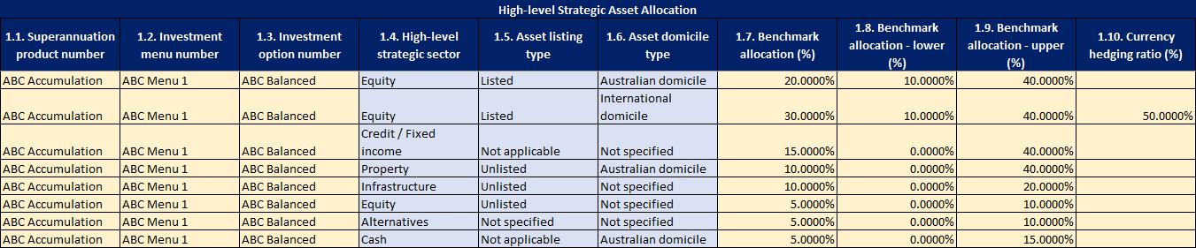
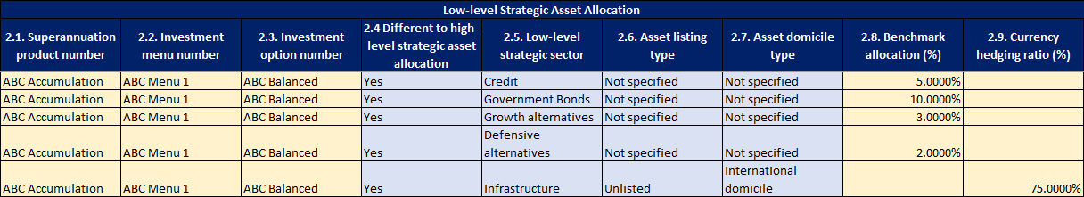
As ABC Superannuation set their strategic asset allocation at a more granular level than that which is available in the high-level strategic asset allocation table, they break their “Credit / Fixed Income” and “Alternatives” allocations into the more granular buckets in the low-level strategic asset allocation table. Additionally, as the currency hedging ratio for the infrastructure allocation only applies to the internationally domiciled component of the infrastructure allocation, this is split out in the low-level table.
All low-level benchmark allocations should map back up to their respective high-level strategic sector in the high level SAA and equate to the same overall benchmark allocation. For instance, in the example above the “Credit” allocation of 5% and the “Government Bonds” allocation of 10% map back to the “Credit/Fixed Income” high-level allocation of 15%. The same is the case for the “Alternatives” allocations.
As currency hedging is implemented at the asset class level and not the investment option level, the “Currency Exposure” high-level strategic sector is not used.
Note that the reporting of zero in the currency hedging ratio column indicates a target of 0% has been set. Leaving the cell blank indicates either no target has been set or it’s not applicable to the asset class.

XYZ Superannuation
XYZ Superannuation’s Investment Policy Statement (IPS) indicates the following strategic asset allocation for their Balanced investment option, which sets a currency exposure target at the investment option level:

Asset Class | Allocation | Lower | Upper
Australian equities | 20% | 10% | 40%
International equities | 30% | 10% | 40%
Fixed interest | 15% | 0% | 30%
Property | 10% | 0% | 20%
Infrastructure | 10% | 0% | 40%
Alternatives | 10% | 0% | 20%
Cash | 5% | 0% | 10%

 | Target | Lower | Upper
Currency Exposure | 20% | 15% | 25%

XYZ Superannuation submit the following high-level and low-level strategic asset allocation:
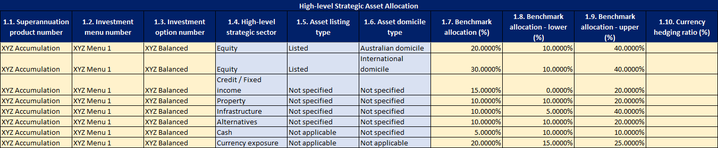
As XYZ Superannuation set their currency exposure at the investment option level, they report the currency exposure target using the “Currency Exposure” high level strategic sector.
Additionally, as XYZ Superannuation do not require further granularity in describing their strategic asset allocation than what’s available in the high-level, they submit “No” for column 2.4 for the investment option.
DEF Superannuation
DEF Superannuation offers a range of investment options, some of which are managed funds and model portfolios offered by investment managers external to the fund. Two such options are the Investment Manager A Global Fund and the Investment Manager B Equities Model Portfolio.
In disclosing the strategic asset allocation of the Investment Manager A Global Fund, DEF Superannuation reports the following:
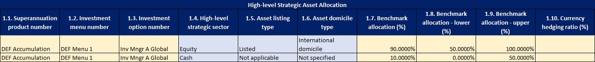

In disclosing the strategic asset allocation of the Investment Manager B Equities Model Portfolio, DEF Superannuation reports the following:
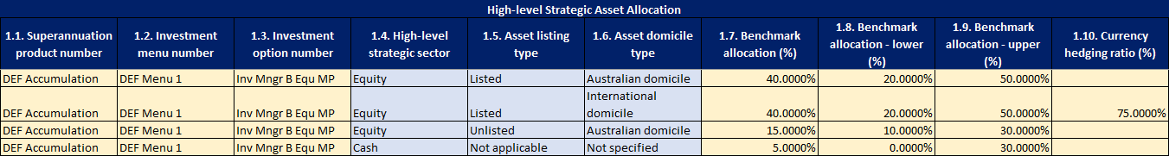
While members invested in model portfolios are at liberty to alter their investment strategy from that of the model, the strategic allocations of said model are still required.

SRF 550.0: Table 2, Actual Asset Allocation
XYZ Superannuation
XYZ Superannuation invests assets of the XYZ Balanced option in a broad range of strategic sectors embodying a number of asset class characteristic combinations. Within the listed international equities asset class, members are exposed to equities ranging from micro cap to large cap, stemming from both developed and emerging markets and invested into using both active and passive management strategies.
XYZ Superannuation report listed international equity and currency exposure investments through the following submission:
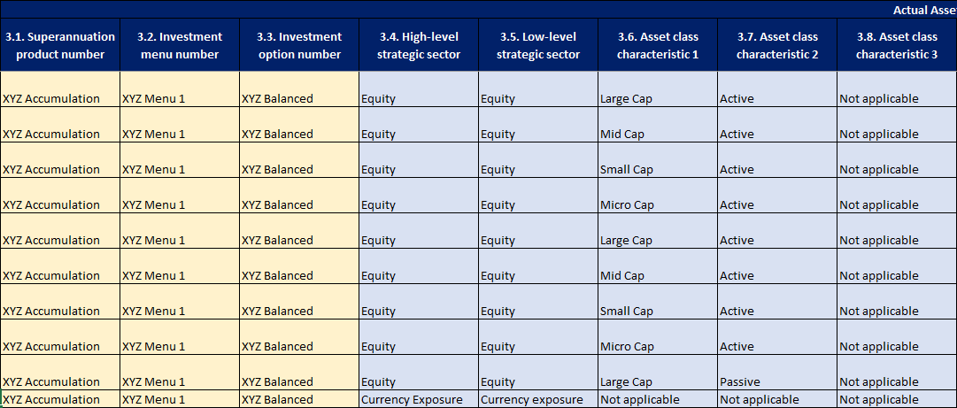

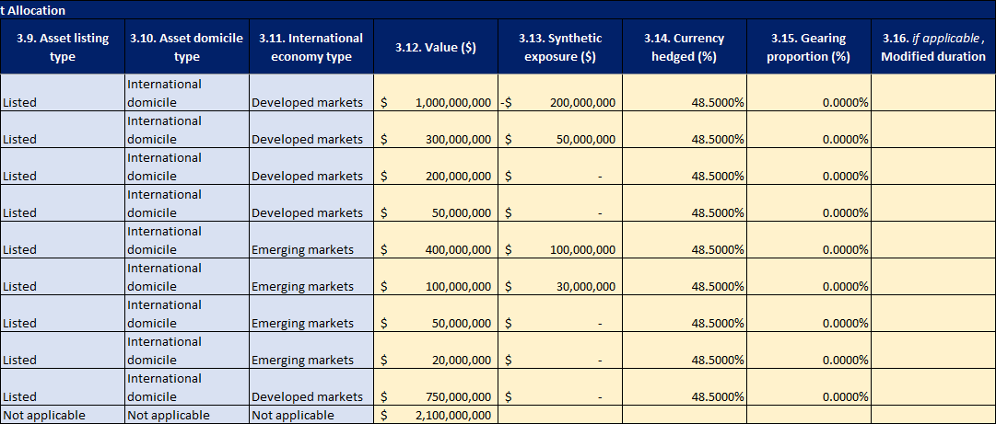
Note that for the sake of brevity, this is only a partial submission and investments pertaining to all the strategic sectors reported in the SAA would be expected to have their exposures reported.
As XYZ Superannuation only has exposure to large cap equities from domestic markets within passive strategies, no further information is required for the passive asset class characteristic.
Note that as no gearing is used and, as the investment does not belong to the credit/fixed income high level strategic sector, modified duration is not applicable, these variables are filled with zeroes and blanks respectively.
As synthetic exposure, currency hedging, gearing proportion and modified duration are not applicable to the currency exposure value, these are left blank.
DEF Superannuation
Borrowing from the earlier example for DEF Superannuation, the fund offers a multitude of options, one of which is Investment Manager B Equities Model Portfolio. The actual asset allocation is the following:
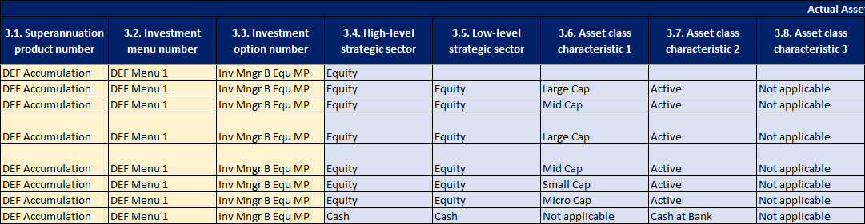
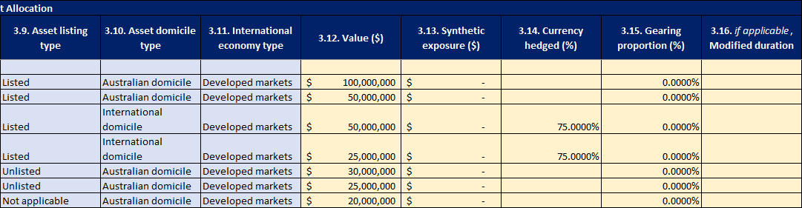
As members are able to diverge from the investment strategy of the model portfolio, the actual asset allocation of the option will not necessarily equate to the strategic asset allocation levels in these instances. Above, it can be seen that members have pulled out from international assets, with the actual allocation falling short of the SAA targets.

