# SRS 251.0 Insurance - Worked example

#### Introduction

This document details a simplified example of reporting under draft “SRS 251.0 Insurance”(SRS 251.0) to provide clarity and promote consistency in compiling pilot data and submission responses for consultation on this topic.

An Excel file is enclosed at the end of this document to provide further illustration.

#### SRF 251.0: Table 1, Current insurance arrangements

In the example for this table, a simplified example fund is presented with the following characteristics:

* Two insurance arrangements:
  + a standard group policy for its general membership (insurance cluster number: ins1).
  + Ten individual policies aggregated into a single insurance cluster as they have a common insurer (insurance cluster number: ins2).
* Both arrangements are open to new members and are in force.

#### SRF 251.1: Table 1, Insurance offerings

Further to the above sample fund, its insurance offerings hold the following characteristics:

* The standard group policy arrangement (ins1) offers bundled life, TPD and IP insurance.
* The ten individual polices offer life only.
* All members are in the same superannuation product (abc123).



#### SRF 251.1: Table 2, Member insurance choice

Following on from the example in SRF 251.1 table 1, member take up of the insurance is shown below.

* The standard group policy arrangement (ins1) offers bundled life, TPD and IP insurance. Of the 1,000,000 members included in this arrangement, 100,000 members have chosen to cancel their life and TPD cover but retain IP.
  + The example shows that 900,000 hold the default level of cover for Life and TPD, with 1,000,000 holding the default level of IP cover.
* Members with the ten individual policies (ins2) started with no cover under this policy by default, but have increased it by taking out the individual policy.

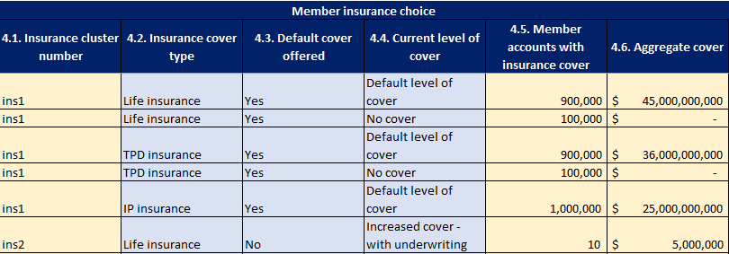

#### 

#### SRF 251.2: Table 2, Claims admitted and paid

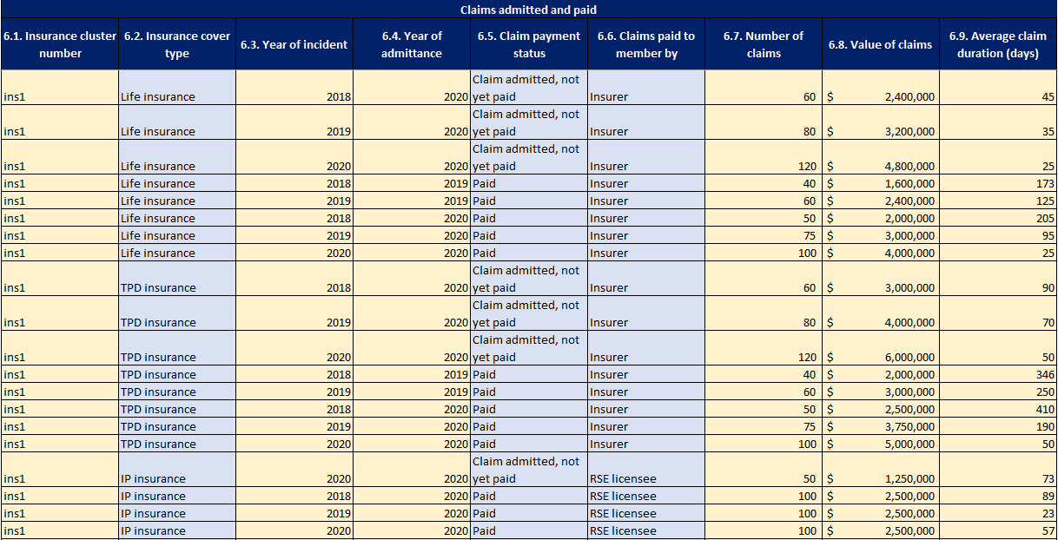All claims admitted or paid during the reporting period should be reported at this item.

#### SRF 251.2: Table 3, Claims processing

This table shows the movement through various states of claim processing during the period.

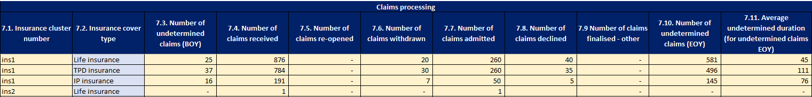

#### SRF 251.3: Table 1, Insurance tables

The fund offers insurance to two groups of members: purple workers (lower risk) and orange workers (higher risk). The definitions of each of these groups overlap with more than one of the Category 1-6 occupation definitions provided. Accordingly ‘Yes’ has been selected for the Categories that overlap with the respective definitions of purple workers and orange workers. Note that both definitions overlap with the Category 3 occupations, so ‘Yes’ has been selected for both workers categories for Category 3 occupations.

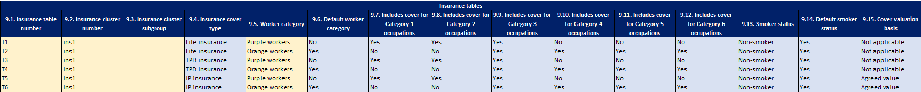

#### SRF 251.3: Table 2, Insurance premiums

Separate premiums are provided for all available ages for each table specified in SRF 251.3. Only T6 has different premiums for male and female workers, so the others have been specified as ‘Aggregate’ meaning that all workers in this category have been combined into a single premium. The waiting period and benefit periods have been specified for tables T5 and T6 which relate to IP insurance.

Please see the SRS 251.0 Insurance - Worksheet for the full example.